[All Rights Reserved]

SLIATE

SLIATE

SRI LANKA INSTITUTE OF ADVANCED TECHNOLOGICAL EDUCATION
(Established in the Ministry of Higher Education, vide in Act No. 29 of 1995)

Higher National Diploma in Information Technology
First Year, First Semester Examination – 2016
HNDIT 1103 - Structured Programming

Instructions: No. of questions : 06
Answer only FIVE (05) questions No. of pages : 10
Marking Scheme Time : Three Hours

Question: 01
- Algorithm and Pseudocode. [02 Marks]

- Low Level Languages is a programming language that provides little or no abstraction from a computer's instruction set architecture—commands or functions in the language map closely to processor instructions. Generally this refers to either machine code or assembly language.
- High Level Languages is a programming language such as C, FORTRAN, or Pascal that enables a programmer to write programs that are more or less independent of a particular type of computer. Such languages are considered high-level because they are closer to human languages and further from machine languages.
- Language Translator is a computer program that performs the translation of a program written in a given programming language into a functionally equivalent program in a different computer language, without losing the functional or logical structure of the original code. [03 Marks]

- [04 Marks]

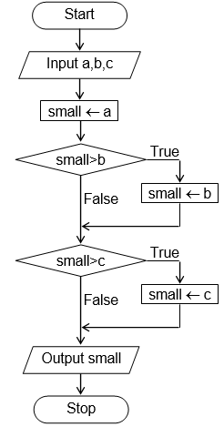 [05 Marks]

- //
- Runtime error
- ;
- iostream.h
- {}
- .cpp [06 Marks]

Question 02.
- >> and <<. [02 Marks]

- char
- float
- long [03 Marks]

Variable is a named memory location to hold a particular type of data and the content of a variable can be changed during the execution of the program.
Constant is a named memory location to hold a particular type of data and the content of a constant cannot be changed during the execution of the program. [04 Marks]

- Only Alphabets,Digits and Underscores are permitted.
- Identifier name cannot start with a digit.
- Key words cannot be used as a name.
- Upper case and lower case letters are distinct.
- Special Characters are not allowed
- Global Identifier cannot be used as “Identifier”. [05 Marks]

#include <iostream.h>
void main()
{
const PI=22.0/7;
int r,h;
float v;
cout<<"Enter radius and height:";
cin>>r>>h;
v=PI*r*r*h;
cout<<"The volume is "<<v<<endl;
} [06 marks]

Question: 03

if(boolean_expression)
{
// statement(s) will execute if the boolean expression is true
}
else
{
// statement(s) will execute if the boolean expression is false
}

switch(expression){
case constant-expression :
statement(s);
break; //optional
case constant-expression :
statement(s);
break; //optional
// you can have any number of case statements.
default : //Optional
statement(s);
} [02 Marks]

- CDF [03 Marks]

- B [04 Marks]

#include <iostream.h>
void main()
{
int marks;
char grade;
cout<<"Enter the marks: ";
cin>>marks;
if (marks>=75)
grade=’A’;
else if (marks>=60)
grade=’B’;
else if (marks>=40)
grade=’C’;
else
grade=’F’;
cout<<"The grade is "<<grade<<endl;
} [05 Marks]

#include<iostream.h>
void main()
{
float cv, rs;
int cf;
cout<<"1.USA Dollar"<<endl;
cout<<"2.UK Pound"<<endl;
cout<<"3.EU Euro"<<endl;
cout<<"Enter the Number of the Currency Format: ";
cin>>cf;
cout<<"Enter amount to convert: ";
cin>>cv;
switch(cf)
{
case 1: rs= cv*143.76; break;
case 2: rs=cv*206.74; break;
case 3: rs=cv*162.48; break;
default: cout<<"Invalid Currency Format";
}
cout<<"Converted Value: "<<rs;
} [06 Marks]

Question: 04

A loop is a sequence of instruction s that is continually repeated until a certain condition is reached.
An infinite loop (sometimes called an endless loop ) is a piece of coding that lacks a functional exit so that it repeats indefinitely. [02 Marks]

for ( init; condition; increment )
{
statement(s);
}

while(condition)
{
statement(s);
}

do
{
statement(s);
}while( condition ); [03 Marks]

When the break statement is encountered inside a loop, the loop is immediately terminated and program control resumes at the next statement following the loop.
The continue statement works somewhat like the break statement. Instead of forcing termination, however, continue forces the next iteration of the loop to take place, skipping any code in between. [04 Marks]

#include <iostream.h>
void main()
{
for (int i=1; i<=5 ; i++)
{
for (int j =1 ;j<=i ;j++)
cout<<i<<" ";
cout<<endl;
}
} [05 Marks]

0
1
2

13

No output [06 Marks]

Question: 05

- An array is a container object that holds a fixed number of values of a single type. 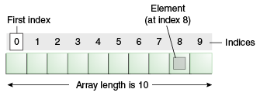
- A pointer points to a memory location which contains data of a particular type. Therefore, the content of a pointer is not data but the address of some data. 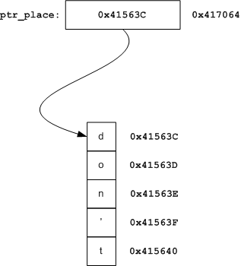 [02 Marks]

#include <iostream.h>
void main()
{
int i, numList[5];
cout<<”Enter 5 numbers:”;
for (i=0; i<5; i++)
cin>>numList[i];
for (i=0; i<5; i++)
cout<<numList[i]; [03 Marks]

- 0x28feec
- 0x28feec
- 0x28fee9
- 10 [04 Marks]

String is C++
De-referenced char pointer is C
String after incrementing is ++
De-referenced char pointer is now +
String after incrementing is + [05 Marks]

spring
summer
winter
winter
winter
fall [06 Marks]

Question: 06

return_type function_name( parameter list )
{
body of the function
} [02 marks]

- An argument in context with functions is the actual value that is passed to the function ( as input) ,when it is called. However parameter refers to the variables that are used in the function declaration/definition to represent those arguments that were send to the function during the function call.
- Pass by value means that the function makes a copy of each parameter which is passed to it, and the original data is unaffected.
- Pass by reference allows the actual variable rather than a copy to be passed to function and the original data is unaffected. [03 marks]

Before swap, value of a : 100
Before swap, value of b :200
After swap, value of a : 100
After swap, value of b : 100 [04 Marks]

int maxInt(int a, int b)
{
if (a>b)
return a;
else
return b;
} [05 Marks]

#include <iostream.h>
void sum(int a, int b, int& c)
{
c=a+b;
}

void main()
{
int x,y,z;
cout<<”Enter two integers:”;
cin>>x>>y;
cout<<”x=”<<x<<<<”y=”<<y<<”z=”<<z<<endl;
sum(x,y,z);
cout<<”x=”<<x<<<<”y=”<<y<<”z=”<<z;
} [06 Marks]

